TABLE OF CONTENTS

- EXECUTIVE SUMMARY

- RESEARCH PROBLEM AND OBJECTIVES

- RESEARCH QUESTION AND HYPOTHESIS

- METHOD

- DATA ANALYSIS

- CONCLUSIONS

- REFERENCES

- APPENDIX

EXECUTIVE SUMMARY
This research investigated the factors influencing young consumers' attitudes toward sustainable fashion. By analyzing data from Macquarie University students, we aimed to understand the impact of demographic factors, individual characteristics, and perceived product attributes on sustainable fashion preferences.
Our findings indicate that gender and age do not significantly affect attitudes toward sustainable fashion. However, fashion consciousness emerged as a key driver, positively correlating with positive attitudes. Interestingly, price consciousness did not significantly influence attitudes.
Perceived product attributes, such as quality, played a crucial role. Consumers who perceived sustainable fashion as high-quality were more likely to hold positive attitudes. This suggests that emphasizing quality and sustainability benefits can effectively attract young consumers.

RESEARCH PROBLEM AND OBJECTIVES

RESEARCH PROBLEM
What are the determinants of young consumers’ attitudes toward sustainable fashion products?

OBJECTIVE ONE
To examine if attitudes toward sustainable fashion differ across population segments.

OBJECTIVE TWO
To understand the relationships between individual characteristics and attitudes toward sustainable fashion.

OBJECTIVE THREE
To evaluate the relationships between perceptions of sustainable fashion features and attitudes toward sustainable fashion.

RESEARCH QUESTION AND HYPOTHESIS

Objective 1: To examine if attitudes toward sustainable fashion differ across population segments.
Research Question 1.1: Does gender influence attitudes towards sustainable fashion?
- Null Hypothesis (H0): There is no significant difference in attitudes towards sustainable fashion between genders.
- Alternative Hypothesis (H1): There is a significant difference in attitudes towards sustainable fashion between genders.

Research Question 1.2: Does age influence attitudes towards sustainable fashion?
- Null Hypothesis (H0): There is no significant difference in attitudes towards sustainable fashion across different age groups.
- Alternative Hypothesis (H1): There is a significant difference in attitudes towards sustainable fashion across different age groups.

Objective 2: To understand the relationships between individual characteristics and attitudes toward sustainable fashion.
Research Question 2.1: Is there a relationship between fashion consciousness and attitudes towards sustainable fashion?
- Null Hypothesis (H0): There is no significant correlation between fashion consciousness and attitudes towards sustainable fashion.
- Alternative Hypothesis (H1): There is a significant correlation between fashion consciousness and attitudes towards sustainable fashion.

Research Question 2.2: Is there a relationship between price consciousness and attitudes towards sustainable fashion?
- Null Hypothesis (H0): There is no significant correlation between price consciousness and attitudes towards sustainable fashion.
- Alternative Hypothesis (H1): There is a significant correlation between price consciousness and attitudes towards sustainable fashion.

Objective 3: To evaluate the relationships between perceptions of sustainable fashion features and attitudes toward sustainable fashion.
Research Question 3.1: Is there a relationship between quality perception of sustainable clothes and attitudes towards sustainable fashion?
- Null Hypothesis (H0): There is no significant correlation between quality perception of sustainable clothes and attitudes towards sustainable fashion.
- Alternative Hypothesis (H1): There is a significant correlation between quality perception of sustainable clothes and attitudes towards sustainable fashion.
Statistical Test: Multiple Linear Regression

Research Question 3.2: Is there a relationship between the distribution perception of sustainable clothes and attitudes towards sustainable fashion?
- Null Hypothesis (H0): There is no significant correlation between the distribution perception of sustainable clothes and attitudes towards sustainable fashion.
- Alternative Hypothesis (H1): A significant correlation exists between the distribution perception of sustainable clothes and attitudes towards sustainable fashion.
Statistical Test: Multiple Linear Regression

METHOD

Population of Interest
The data provided for this project is taken from the students of Macquarie University pursuing the unit Applied Marketing Research. The students were given a Qualtrics survey and data was based on input given by students in the above survey. Students are generally of a younger demographic and more likely to be interested in latest fashion compared to older people.

Sampling Method/ Sampling Size
The sample size ascertained based on the given data is 113. Convenience sampling is the method used, primarily because as the name suggests it is a convenient method for sampling.

DATA ANALYSIS
Affective_Attitude is a composite variable made using Q1 to Q5 (Cranbach Alpha score was 0.7 or greater)
Behaviour_Intention is another composite variable made using Q6 to Q8 (Cranbach Alpha score was 0.7 or greater)
Consumer_Attitude is made using Affective_Attitude and Behavior_Intention.
Fashion_Consciousness, Price_Consciousness and Quality_Perception are also variables made similarly.

Objective 1: To examine if attitudes toward sustainable fashion differ across population segments.
Research Question 1.1: Does gender influence attitudes towards sustainable fashion?
- Null Hypothesis (H0): There is no significant difference in attitudes towards sustainable fashion between genders.
- Alternative Hypothesis (H1): There is a significant difference in attitudes towards sustainable fashion between genders.
Statistical Test: Independent Samples t-test

Step 1
Since the p-value for Levene’s test (0.265) is greater than 0.05 (as seen in APPENDIX A), the assumption of equal variances is held and we report the first line of t-test results.

Step 2
The p-value in the first line of the t-test results (0.103) is greater than 0.05 (as seen in APPENDIX A), and we fail to reject the null hypothesis. This indicates there are no significant differences in attitudes towards sustainable fashion between genders.

Research Question 1.2: Does age influence attitudes towards sustainable fashion?
- Null Hypothesis (H0): There is no significant difference in attitudes towards sustainable fashion across different age groups.
- Alternative Hypothesis (H1): There is a significant difference in attitudes towards sustainable fashion across different age groups.
Statistical Test: One-Way ANOVA
Since the p-value (0.2) is greater than 0.05 (please refer to APPENDIX B), we fail to reject the null hypothesis. This indicates there are no significant differences in attitudes towards sustainable fashion across different age groups.

Objective 2: To understand the relationships between individual characteristics and attitudes toward sustainable fashion.
Research Question 2.1: Is there a relationship between fashion consciousness and attitudes towards sustainable fashion?
- Null Hypothesis (H0): There is no significant correlation between fashion consciousness and attitudes towards sustainable fashion.
- Alternative Hypothesis (H1): There is a significant correlation between fashion consciousness and attitudes towards sustainable fashion.
Statistical Test: Pearson Correlation
Since the p-value (0.05) is equal to 0.05, we fail to accept the null hypothesis (please refer to APPENDIX C). This means there is a significant correlation between fashion consciousness and attitudes towards sustainable fashion.
A correlation coefficient equal to 0.262 indicates there is a weak positive correlation between fashion consciousness and attitudes towards sustainable fashion.

Research Question 2.2: Is there a relationship between price consciousness and attitudes towards sustainable fashion?
- Null Hypothesis (H0): There is no significant correlation between price consciousness and attitudes towards sustainable fashion.
- Alternative Hypothesis (H1): There is a significant correlation between price consciousness and attitudes towards sustainable fashion.
Statistical Test: Pearson Correlation

Since the p-value (0.479) is greater than 0.05, we fail to reject the null hypothesis (please refer to APPENDIX D). This means there is no significant correlation between fashion consciousness and attitudes towards sustainable fashion.
A correlation coefficient equal to 0.067 indicates a very weak or no correlation between fashion consciousness and attitudes towards sustainable fashion.

Objective 3: To evaluate the relationships between perceptions of sustainable fashion features and attitudes toward sustainable fashion.
Research Question 3.1: Is there a relationship between fashion consciousness, quality perception of sustainable clothes, and attitudes towards sustainable fashion?
- Null Hypothesis (H0): There is no significant correlation between fashion consciousness, quality perception of sustainable clothes, and attitudes towards sustainable fashion.
- Alternative Hypothesis (H1): A significant correlation exists between fashion consciousness, the quality perception of sustainable clothes, and attitudes towards sustainable fashion.
Statistical Test: Multiple Linear Regression

Values of R squared (R = 0.268, F = 20.124, p < 0.01) in APPENDIX E tells us that 26.8% of attitudes toward sustainable fashion are being driven collectively by fashion consciousness and quality perception of sustainable clothes. The p-value is less than 0.05 and hence we fail to accept the null hypothesis.
The beta coefficient and corresponding p-value (B = 0.095, p = 0.125) indicate that fashion consciousness has a positive impact on attitude towards sustainable fashion.
The beta coefficient and corresponding p-value (B = 0.437, p < 0.001) indicate that quality perception has a positive impact on attitude towards sustainable fashion.

Research Question 3.2: Is there a relationship between fashion consciousness, price consciousness, and attitudes towards sustainable fashion?
- Null Hypothesis (H0): There is no significant correlation between fashion consciousness, price consciousness, and attitudes towards sustainable fashion.
- Alternative Hypothesis (H1): A significant correlation exists between fashion consciousness, price consciousness, and attitudes towards sustainable fashion.
Statistical Test: Multiple Linear Regression

Values of R squared (R = 0.267, F = 4.221, p = 0.017) in APPENDIX F tells us that 26.7% of attitudes toward sustainable fashion are being driven collectively by fashion consciousness and price consciousness of sustainable clothes. The p-value is less than 0.05 and hence we fail to accept the null hypothesis.
The beta coefficient and corresponding p-value (B = 0.186, p = 0.006) indicate that fashion consciousness has a positive impact on attitude towards sustainable fashion.
The beta coefficient and corresponding p-value (B = 0.046, p = 0.566) indicate that price consciousness has a positive impact on attitude towards sustainable fashion.

CONCLUSIONS
Research Question | Null Hypothesis | Result
Does gender influence attitudes toward sustainable fashion? | There is no significant difference in attitudes towards sustainable fashion between genders. | Accepted
Does age influence attitudes toward sustainable fashion? | There is no significant difference in attitudes towards sustainable fashion across different age groups. | Accepted
Is there a relationship between fashion consciousness and attitudes towards sustainable fashion? | There is no  significant correlation between fashion consciousness and attitudes towards sustainable fashion. | Rejected
Is there a relationship between price consciousness and attitudes towards sustainable fashion? | There is no significant correlation between price consciousness and attitudes towards sustainable fashion. | Accepted
Is there a relationship between fashion consciousness, quality perception of sustainable clothes, and attitudes towards sustainable fashion? | There is no significant correlation between fashion consciousness, quality perception of sustainable clothes, and attitudes toward sustainable fashion | Rejected
Is there a relationship between fashion consciousness, price consciousness, and attitudes towards sustainable fashion? | There is no significant correlation between fashion consciousness, price consciousness, and attitudes towards sustainable fashion. | Rejected

Key Findings:
- Demographic Factors: We see that gender and age did not significantly impact attitudes regarding sustainable fashion. This suggests an appeal for sustainable fashion across the globe, irrespective of demographic differences.
- Psychological Factors: Fashion consciousness emerged as a principal driver of positive attitudes leading to sustainable fashion. This further emphasizes the significance of aligning sustainable fashion with present trends and styles.
- Perceived Product Attributes: Quality perception significantly influences attitudes towards sustainable fashion. Consumers want to embrace sustainable options when they perceive them as high-quality and durable.

Implications From A Managerial Perspective:
- Target the Fashion-Conscious Consumer: Market sustainable fashion to individuals who prioritize style and trendiness.
- Prioritize Quality and Durability: Build trust and loyalty with consumers by investing in high-quality materials and craftsmanship.
- Effective Communication: Communicate the sustainability benefits of products, emphasizing eco-friendly materials, ethical production, and social impact.
- Accessibility and Distribution: Through diverse distribution channels (online and offline stores), ensure sustainable fashion is readily available.
- Pricing Strategy: While price consciousness did not significantly impact attitudes, competitive pricing can enhance accessibility and appeal to a wider consumer base.

Future Research Directions:
- Cultural and Regional Differences: Explore how cultural and regional factors influence attitudes towards sustainable fashion.
- Long-Term Impact of Sustainability Initiatives: Conduct longitudinal studies to assess the long-term impact of sustainability initiatives on consumer behavior.
- Role of Social Influence: Investigate the role of social media and influencers in shaping consumer perceptions of sustainable fashion.

References:
Lee, S. M., & Park, H. W. (2019). The impact of green brand image, perceived value, and environmental concern on green purchase intention: The case of sustainable fashion. Journal of Cleaner Production, 210, 107-118.
Global Fashion Agenda. (2023). Pulse of the Fashion Industry. Copenhagen: Global Fashion Agenda
Roberts, J. (2018). Ethical Fashion: A Guide to Sustainable Style. Bloomsbury Publishing.

APPENDIX A
Research Question 1.1
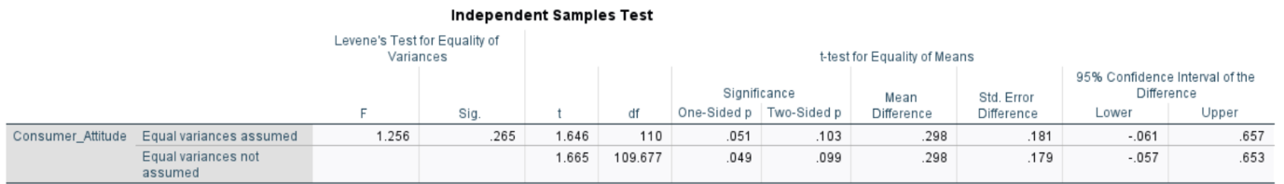

APPENDIX B
Research Question 1.2
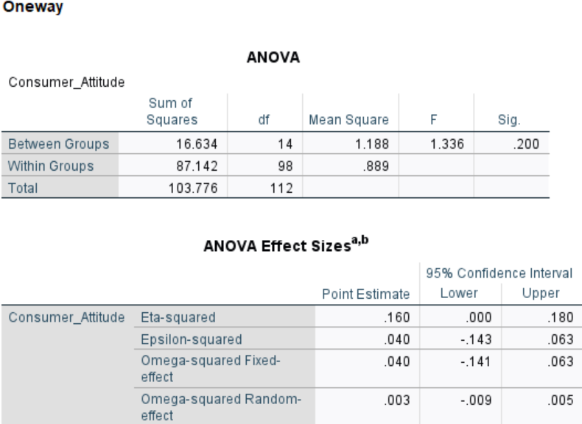

APPENDIX C
Research Question 2.1
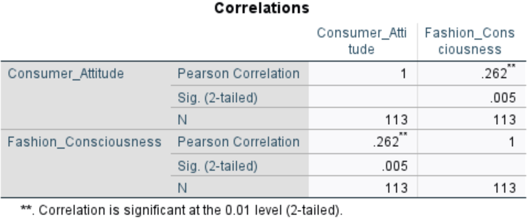

APPENDIX D
Research Question 2.2
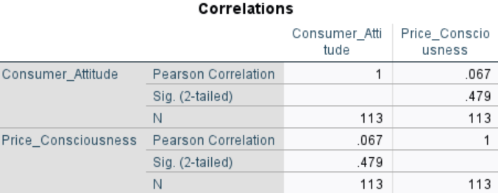

APPENDIX E
Research Question 3.1
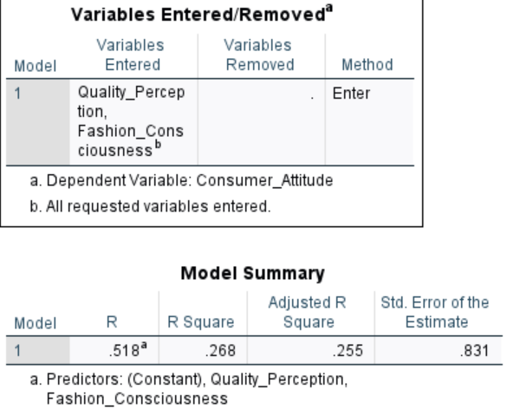

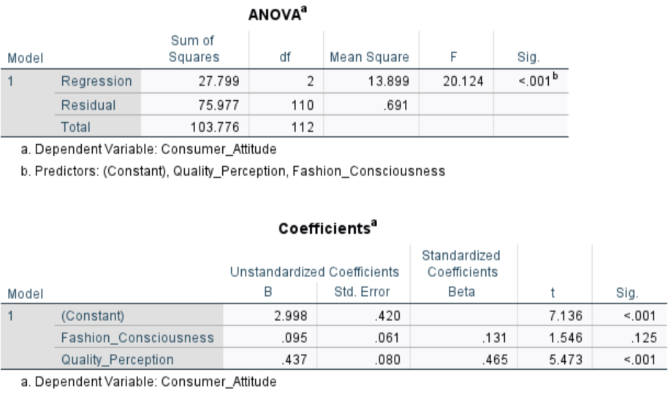

APPENDIX F Research Question 3.2